**Online Psychiatry Application**

Submitted in partial fulfillment of the requirements of

**Mini Project (CSM501)**

for

Third Year of Computer Engineering

By

Bhumi Avhad - 20102B2002

Sapana Survase - 20102B2005

Rahul Shewale - 20102A2003

Harsh Pandita - 19102A0040

Under the Guidance of

Prof. Divya Surve

Department of Computer Engineering

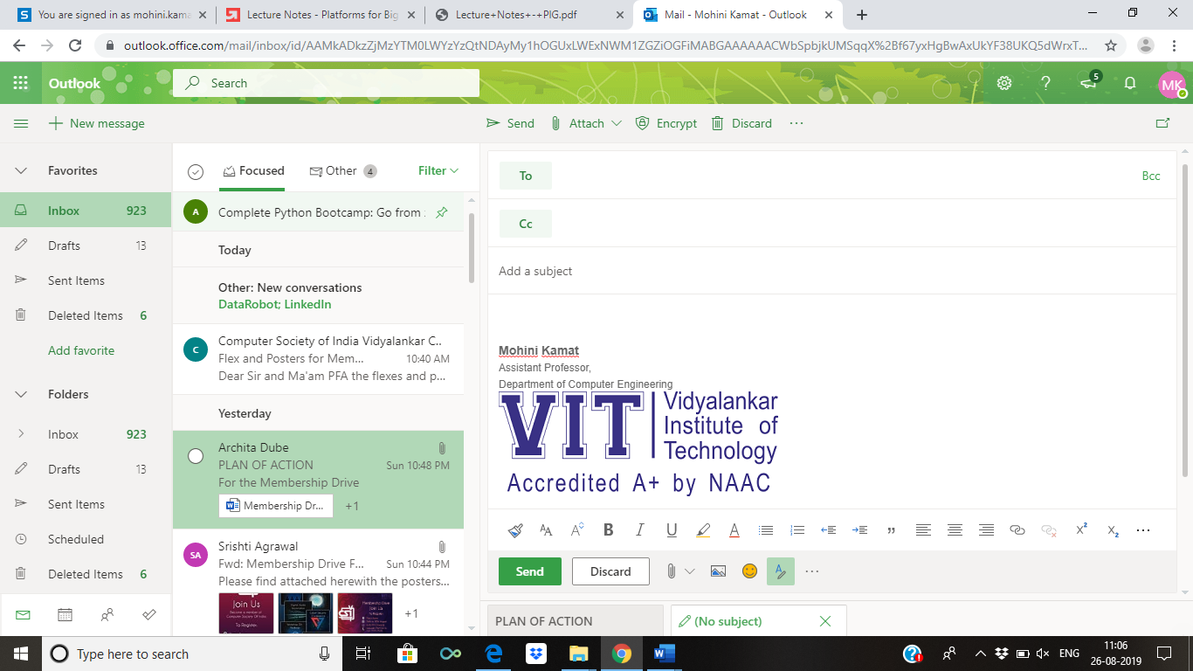

Vidyalankar Institute of Technology

Wadala(E), Mumbai-400437

University of Mumbai

2021-22

**CERTIFICATE OF APPROVAL**

This is to certify that the project entitled

**“Online Psychiatry Application”**

is a bonafide work of

**Bhumi Avhad - 20102B2002**

**Sapana Survase - 20102B2005**

**Rahul Shewale - 20102A2003**

**Harsh Pandita - 19102A0040**

submitted to the University of Mumbai in partial fulfillment of

**Mini Project (CSM501)**

for

Third Year of Computer Engineering

Guide Head of Department Principal

Prof. Divya Surve Dr. Sachin Bojewar Dr. Sunil Patekar

Mini Project Report Approval

This project report entitled **Online Psychiatry Application** by

1. **Bhumi Avhad 20102B2002**
2. **Sapana Survase 20102B2005**
3. **Rahul Shewale 20102A2003**
4. **Harsh Pandita 19102A0040**

is approved for Mini Project (CSM501) for Third Year of Computer Engineering.

|  |  |
| --- | --- |
| Internal Examiner | External Examiner |

Date:

Place:

Declaration

I declare that this written submission represents my ideas in my own words and where others' ideas or words have been included, I have adequately cited and referenced the original sources. I also declare that I have adhered to all principles of academic honesty and integrity and have not misrepresented or fabricated or falsified any idea/data/fact/source in my submission. I understand that any violation of the above will be cause for disciplinary action by the Institute and can also evoke penal action from the sources which have thus not been properly cited or from whom proper permission has not been taken when needed.

|  |  |  |
| --- | --- | --- |
| Name of student | Roll No. | Signature |
| Bhumi Avhad | 20102B2002 |  |
| Sapana Survase | 20102B2005 |  |
|  |  |  |
| Rahul Shewale | 20102A2003 |  |
| Harsh Pandita | 19102A0040 |  |
|  |  |  |
|  |  |  |
|  |  |  |
|  |  |  |

Date:

Place:

Acknowledgements

This Project wouldn’t have been possible without the support, assistance, and guidance of a number of people whom we would like to express our gratitude to. First, we would like to convey our gratitude and regards to our mentor **Prof. Divya Surve** for guiding us with his constructive and valuable feedback and for his time and efforts. It was a great privilege to work and study under his guidance.

We would like to extend our heartfelt thanks to our Head of Department, **Dr. Sachin Bojewar** for overseeing this initiative which will in turn provide every Vidyalankar student a distinctive competitive edge over others.

We appreciate everyone who spared time from their busy schedules and participated in the survey. Lastly, we are extremely grateful to all those who have contributed and shared their useful insights throughout the entire process and helped us acquire the right direction during this research project.

Abstract

In today's generation mental health disorder which is mainly affecting many people's lifestyles especially the youth generation. As the number of psychotherapists is not enough, it is necessary for people to be able to keep their mental wellness on their own.

There are lot of applications evolved for mental health disorders and recent reviews of application shows that online therapists are distant from the client, it can be difficult for them to respond quickly and effectively.

Hence the ultimate aim is to provide an effective application which has the ability to give the solution or solve the problems via chatbot and if the situation is serious then assist the therapist.

For these the sentiment analysis will be referred in which the natural language processing, text analysis and computational linguistics to study subjective states of the text presented. Using datasets freely available online, we can train models(chatbot) and then us sentiment analysis to find out if the user’s response is positive, neutral or serious, and thus decide the response accordingly.

**Table of Contents**

|  |  |  |
| --- | --- | --- |
| **Sr No** | **Description** | **Page No** |
| 1 | Introduction | 8 |
| 2 | Problem Definition | 11 |
| 3 | Literature Survey | 12 |
| 4 | Conclusion | 14 |
| 5 | References | 15 |

Introduction

Psychiatry means the branch of medicine concerned with the study, diagnosis, and treatment of mental illness.

Access to mental health services and treatment remains an issue in all countries and cultures across the globe. Worldwide, major depression is the leading cause of years lived with disability and the fourth leading cause of disability-adjusted life years (DALYs). So, it is clear that there is a need for new solutions and innovation in mental health.

Unfortunately, the current clinical workforce is insufficient in meeting these needs. There are approximately 9 psychiatrists per 100,000 people in developed countries[1](https://journals.sagepub.com/doi/full/10.1177/0706743719828977) and as few as 0.1 for every 1,000,000[4](https://journals.sagepub.com/doi/full/10.1177/0706743719828977) in lower-income countries. This inadequacy in meeting the present or future demand for care has led to the proposal of technology as a solution. Particularly, there is a growing interest surrounding chatbots, also known as conversational agents or multipurpose virtual assistants.

Chatbots or conversational agents are here defined as digital tools existing either as hardware (such as an Amazon Echo running the Alexa digital assistant software) or software (such as Google Assistant running on Android devices or Siri running on Apple devices) that use machine learning and artificial intelligence methods to mimic humanlike behaviours and provide a task-oriented framework with evolving dialogue able to participate in conversation (see Figure_1). Gaining traction in the popular press, their potential in mental health is well represented, considering one of the top requests to Alexa during the summer of 2017 was “Alexa, help me relax,” according to the *MIT Technology Review*.

[
                        figure
                    ](https://journals.sagepub.com/doi/full/10.1177/0706743719828977)

**Figure 1.** A sample interaction between a patient and a chatbot therapist.

This human-computer interaction technology was established academically half a century ago. In 1964, the programmable natural language processing program ELIZA was developed at the MIT Artificial Intelligence laboratory by Joseph Weizenbaum. Designed to act as a Rogerian psychotherapist, ELIZA could not understand the content of its conversations. However, many who used this chatbot believed it to be intelligent enough to comprehend conversation and even became emotionally attached to it. Weizenbaum would later remark that “[he] had not realized…that extremely short exposures to a relatively simple computer program could induce powerful delusional thinking in quite normal people.” In 1972 at Stanford University, psychiatrist Kenneth Colby developed PARRY, a program capable of simulating the behaviour of a human with schizophrenia that was then “counseled” several times by ELIZA.

Although there is still much to be explored when it comes to chatbots in mental health, their potential has already begun to surface. Chatbots are being used in suicide prevention and cognitive-behavioural therapy, and they are even being tailored to certain populations, such as HARR-E and Wysa. In particular, chatbots may be helpful in providing treatment for those who are uncomfortable disclosing their feelings to a human being. Therefore, virtual therapy provided by a chatbot could not only improve access to mental health treatment but also be more effective for those reluctant to speak with a therapist. Veterans, for example, who are often reluctant to open up after a tour of duty, were significantly more likely to open up to a chatbot when told it was a virtual therapist than those who were told the chatbot was being controlled by a person offering the potential to increase needed access to care.

With increased access to technology and the ease of use that accompanies, interest in mental health chatbots has reached a point where some have labelled them “the future of therapy.” However, there is no consensus on the definition of psychiatric chatbots or their role in the clinic. While they do hold potential, little is known about who actually uses them and what their therapeutic effect may be. Evaluation efforts are further complicated by the rapid pace of development in hardware and that such software may behave and respond differently depending on region. For example, when a user said he or she felt sad, one chatbot, the US-developed Google Assistant, replied, “I wish I had arms so I could give you a hug,” where the Russian-developed chatbot Alisa replied with “No one said life was about having fun.”

Problem Definition

* As the number of psychotherapists is not enough, it is necessary for people to be able to keep their mental wellness on their own.
* There are lot of applications evolved for mental health disorders and recent reviews of application shows that online therapists are distant from the client, it can be difficult for them to respond quickly and effectively.

Literature Survey

* **Digital Psychiatry - Curbing Depression using Therapy Chatbot and Depression Analysis**

**Published in:** 2018 Second International Conference on Inventive Communication

**Published by:** Bhuvan Sharma, Harshita Puri, Deepika Rawat

**Funding:** The author(s) received no financial support for the research, authorship, or publication of this article.

The objective of this research is to devise a cognitive behavioural therapy system or a Therapy Chatbot capable of catering to the health and informative needs of a user. Also, the key focus is on the therapy element which detects the level of depression in a particular individual. This study is intended to target 300 million people worldwide.

The system not only detects the level of depression in an individual but also suggests remedies to lower the level of depression in an individual. This study uses python as the base language which can be integrated with android so as to serve as a messaging platform so that it can target a larger audience. It is designed in such a way that it can emulate a psychotherapist.

* **Chatbot and Conversational Agents in Mental Health**

**Published in:** March 21, ‘19 PubMed, EmBase, PsycINFO, Cochrane, Web of Science, and IEEE Xplore

**Published by:** Aditya Vaidyam, Hannah Wisniewski, John Halamka, Matcheri Kashavan and John Torous.

**Funding:** The author(s) received no financial support for the research, authorship, and/or publication of this article.

The aim of this review was to explore the current evidence for conversational agents or chatbots in the field of psychiatry and their role in screening, diagnosis, and treatment of mental illnesses. From the selected databases, 1466 records were retrieved and 8 studies met the inclusion criteria.

Preliminary evidence for psychiatric use of chatbots is favourable. However, given the heterogeneity of the reviewed studies, further research with standardized outcomes reporting is required to more thoroughly examine the effectiveness of conversational agents. Regardless, early evidence shows that with the proper approach and research, the mental health field could use conversational agents in psychiatric treatment.

* **A neural network prediction model for a psychiatric application**

**Published in:** 16-18 Aug, ‘05Sixth International Conference on Computational Intelligence and Multimedia Applications (ICCIMA'05)

**Published by:** K.R. Linstrom**,** A.J. Boye

**Funding:** The author(s) received no financial support for the research, authorship, and/or publication of this article.

This paper presents a unique application of artificial neural networks used to predict the successful or unsuccessful completion of special education programming for students diagnosed with serious emotional disturbance (SED).

In this study, as is common in medical applications, there is an insufficient amount of input data for training and testing the neural network. Bootstrapping and noisy replication of the input data are two techniques used to attempt to compensate for this small amount of available data. While the results would have benefited if more data were available, the results show some promise in being able to correctly predict the successful or unsuccessful completion of SED programming with artificial neural networks, particularly as a diagnostic test.

## **Conclusion**

Chatbots offer the potential of a new and impactful psychiatric tool, provided they are implemented correctly and ethically. As Google recently announced its Duplex AI sounding indistinguishable from a typical person and capable of booking appointments or restaurant tables without any illusory gap, there will likely come a day where conversation between people and person to chatbot is not only commonplace but mainstay. Today there is a lack of a higher quality evidence for any type of diagnosis, treatment, or therapy in mental health research using chatbots. With the right approach, research, and process to clinical implementation, however, the field has the opportunity to harness this technology revolution and stands to gain arguably the most from chatbots than any other field of medicine.

So, we hope that with the help of these technology our Online psychiatric application will help to overcome the mental issue he/she facing.

References

**Documentation**

* Chatbots and Conversational Agents in Mental Health: A Review of the Psychiatric Landscape.” The Canadian Journal of Psychiatry. -

<https://journals.sagepub.com/doi/full/10.1177/0706743719828977>

* Digital Psychiatry - <https://ieeexplore.ieee.org/document/8472986>
* A neural network prediction model for a psychiatric application - [https://ieeexplore.ieee.org/document/1540700/citations#citations](https://ieeexplore.ieee.org/document/1540700/citations)

**Chatbot**

* Depression Therapy using Chatbot -<https://www.facebook.com/Chatbot.Brad>

**Dataset**

* <https://www.techwithtim.net>
* <https://archive.ics.uci.edu/ml/datasets/Student+Performance>